How do you ignore a test in a class?

By putting @ignore annotation against any test in a class. By doing this the test will not get executed while running against which the @ignore annotation is defined.

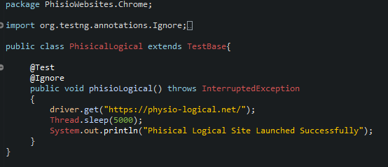

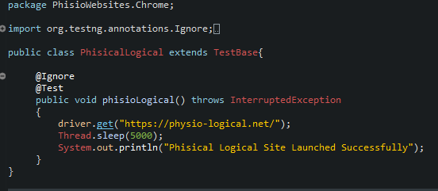

@Ignore annotation can be put before the @Test / after the @Test annotation

By putting @ignore annotation against any class you can ignore all the tests defined in that class to be executed.

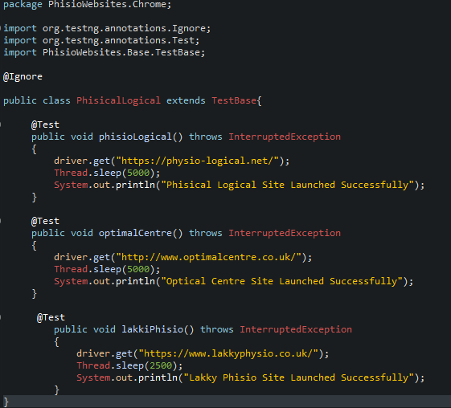

You can also all the classes inside a particular package. How to do that -

Example : I want to ignore all the class files to be executed under PhisioWebsites.Chrome folder

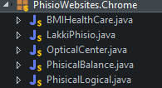

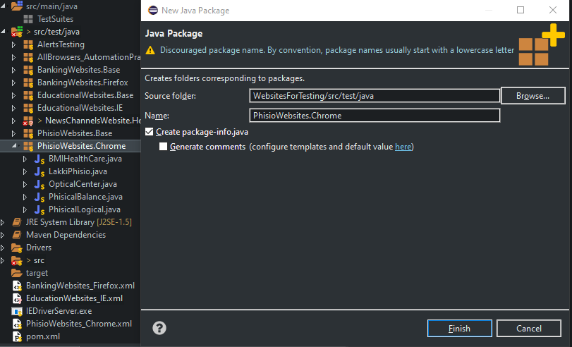

You need to create a new package with the same package name for which you don’t want the test cases to be run.
Make sure that the Create package-info.java checkbox is selected.
And click on Finish button

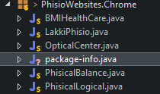

You can now see that there is a new file created by the name "package-info.java"

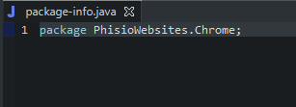

Now add the following line into the "package-info.java" file.

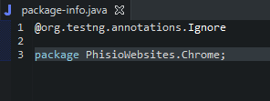

After doing the above steps and if you try to run any of the testcases individually or through suite.xml file - none of the test cases will be executed
Because the @ignore condition is put against the package.

